Nama : Fawaz Al Rasyid

NIM : 1301213016

Flight.h

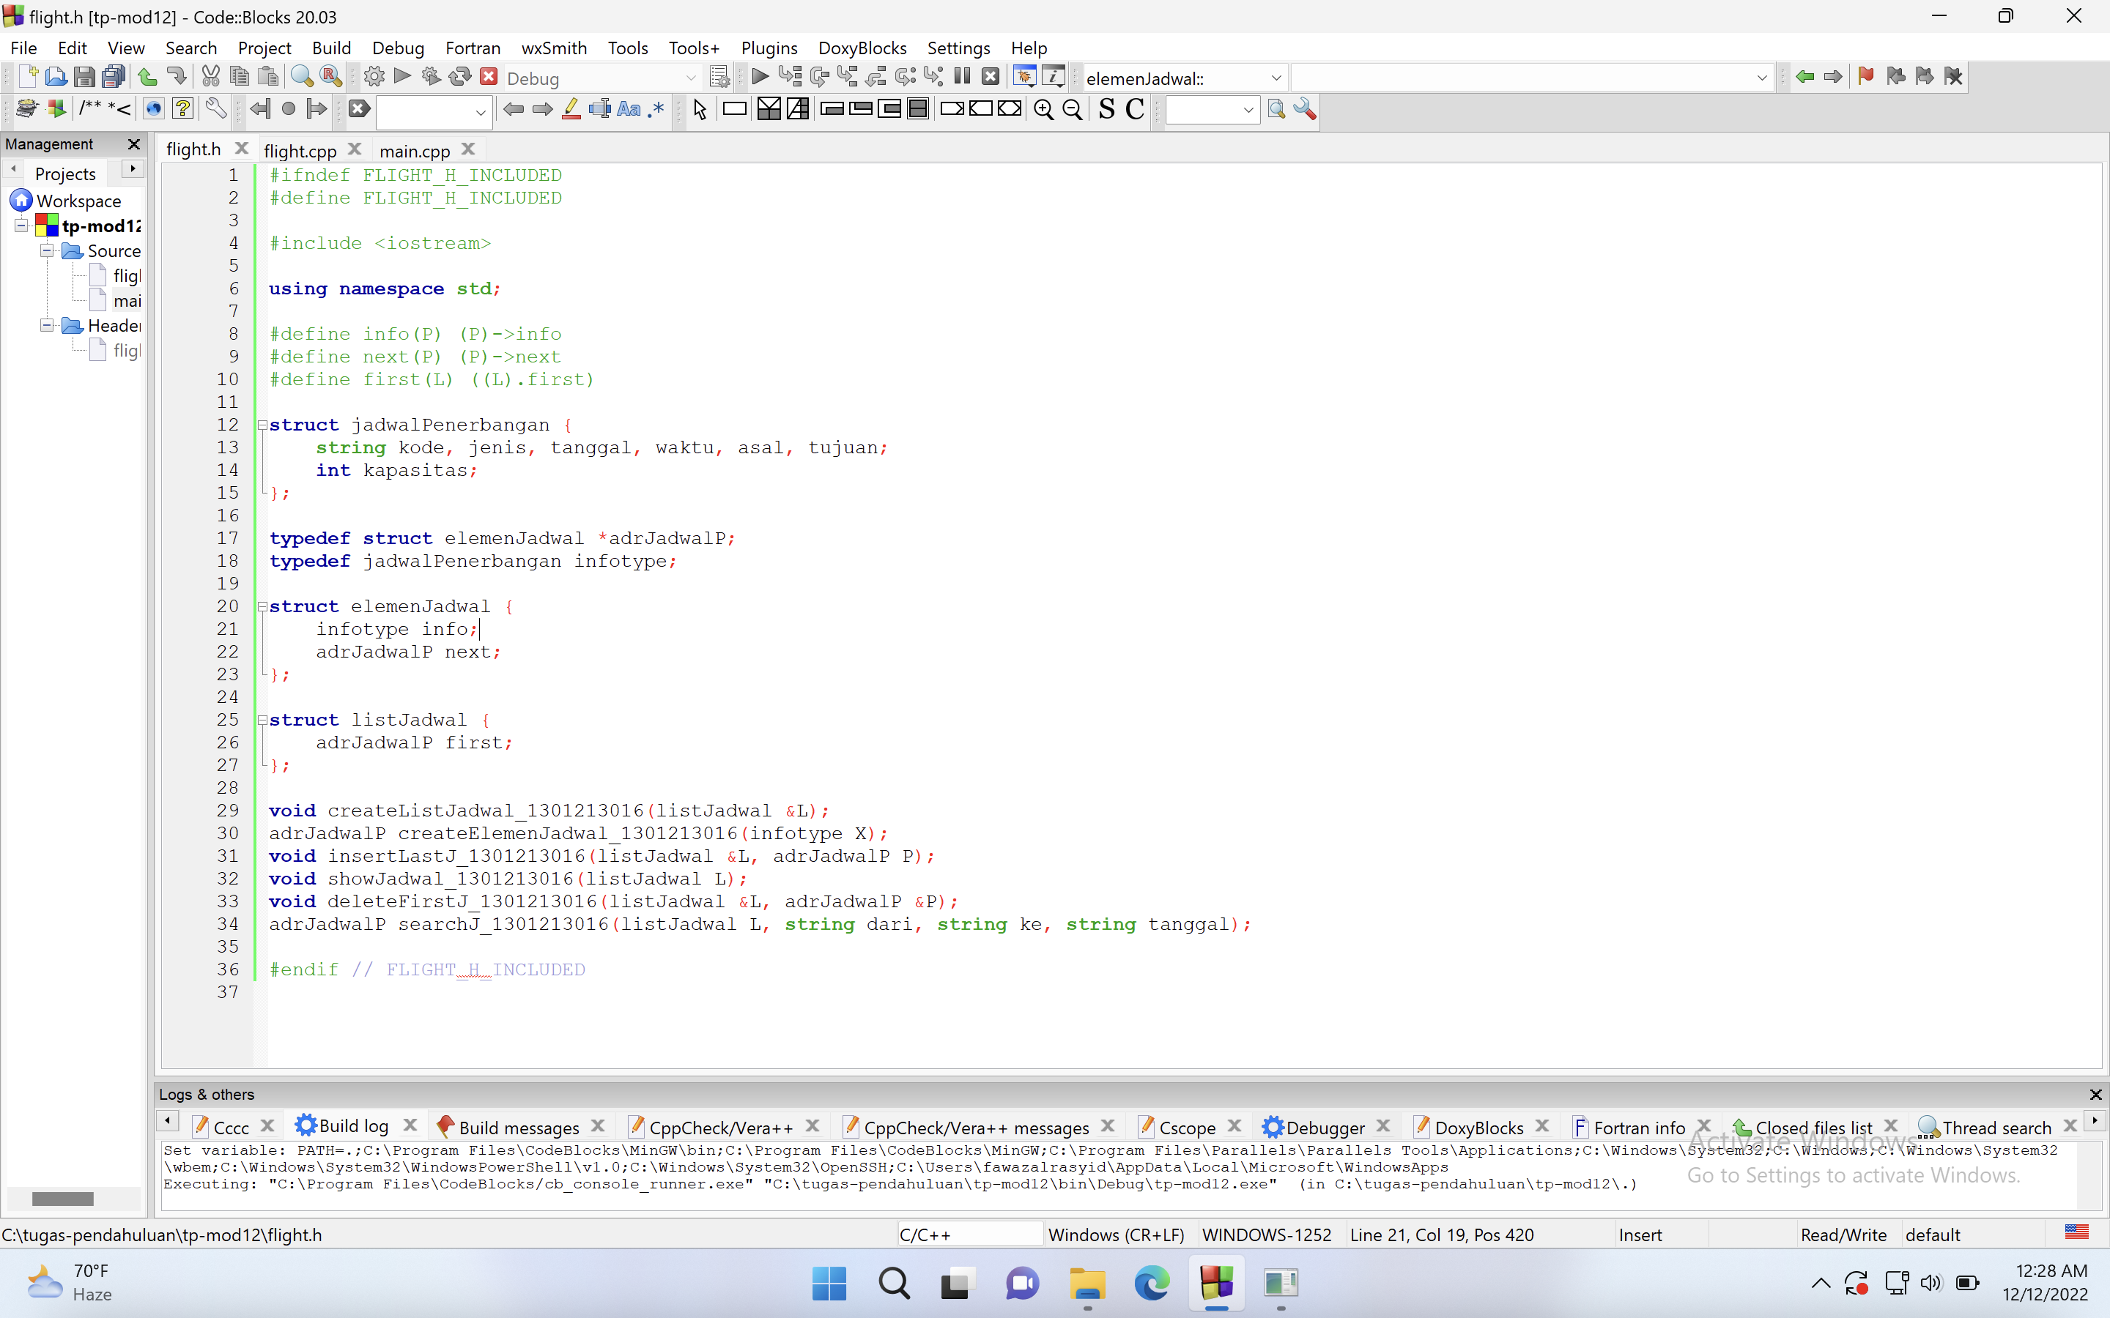

Flight.cpp

Main.cpp

Output

